**Travis County, Texas**

**Statement of Intent**

**For**

**The STAR-Vote Entity**

This Statement of Intent (SOI) is to inform Interested Parties of Travis County’s intent for the long term management and support of STAR-Vote: A New Voting System. As an Open Source Software (OSS) product, the STAR-Vote voting system requires continuing development, management of the code base and the system certification maintained. Performance of these functions is beyond the scope of Travis County’s capabilities and is well suited for a separate entity to conduct. The type of entity can take several forms but the likely type is a non-profit entity, which is the approach employed by the commercial OSS products. For the purpose of this SOI, a non-profit type of entity is used to outline the organizational structure and governance architecture that is customary for OSS products and includes the projected business approach for the non-profit to be self-sustaining within five years of launching the entity.

This document includes the following information as related to the non-profit organization, whereinafter called the STAR-Vote Entity:

* Structuring Period
* Use of Funds
* Membership Types
* Revenue Model
* Financial Contribution

Travis County’s intent is to create a home for STAR-Vote, an Open Source Software (OSS) product. The entity outlined in this SOI is modeled after current practices used by other successful Open Source Software Foundations (OSSF), which are all organized as non-profit foundations.

**PURPOSE/OVERVIEW**

The purpose of this SOI is to solicit interest from Counties, States and other public and private entities that have a long term interest in the use and availability of an open source software voting system that runs on commercial-off-the-shelf hardware for conducting governmental elections in the United States. This is a complementary effort to STAR-Vote™: A New Voting System, RFP# P1609-008-LC released by Travis County and this document proposes the infrastructure necessary to manage, maintain and modify the STAR-Vote system for all that want to adopt it.

Travis County is interested in other parties to become a part of a modern and imaginative election solution that incorporates quality software design and development to provide improved security, transparency, accuracy, reliability, usability, accessibility, and affordability in the election process. STAR stands for Secure, Transparent, Auditable, and Reliable. The STAR-Vote™ system sets new standards using the accuracy of electronic voting, the security of cryptography, the transparency of paper vote records, the auditability of each step of the election process, and the ability to reliably confirm the correct outcomes of each election.

***Why STAR-Vote? Why be a part of this project?*** The requirements for STAR-Vote began from a clean sheet of paper several years ago to embody the characteristics listed. The STAR-Vote was designed with these characteristics at the core, not added in later for marketability.

***What does this mean?***

* Security; the system is built around a cryptographic architecture that was designed for a voting system by some of the nation’s leading cryptographers, rather than adapting something designed for a different solution;
* Transparency; as an Open Source Software product, the software code is visible to all to learn how it works, eliminating the complaint the nation’s elections are conducted on ‘secret code’, which surfaces in the media for every election;
* Auditability; the system designed for a thorough and complete audit down to individual contests in a timely manner using a cost-effective and reliable method;
* Reliability; Commercial Off-The-Shelf (COTS) hardware (like a tablet personal computer) are some of the most reliable products in the world and be constantly tested by large manufactures and general public;
* Cost effectiveness; Travis County estimates that replacing their current system with a traditional voting system will cost $32 million over five years. If this SOI is successful, Travis County estimates that STAR-Vote will cost 75% less and other Counties will realize these savings as well;
* Long-Term Solution; With a non-profit entity managing the software, the users managing the non-profit and the interchangeability of COTS hardware, STAR-Vote can feasibly be the last voting system a county will ever need.
* Timely: The nation largely replaced their systems approximately 10-15 years ago using dollars from the Help America Vote Act and are in the need of system replacement in the next 1 to 5 years.

***It’s time for a change and the time is now – get involved!***

As an Open Source Software (OSS) product, STAR-Vote requires a home – an entity to manage the code base, moderate changes, updates or alternative functional implementations, manage Federal and State certifications and schedule new releases to support its user community. The infrastructure to provide these services will likely take the form of a non-profit organization and this SOI provides a framework for how it would be accomplished. Travis County seeks participation from Interested Parties to become a member of the entity and contribute to the operating budget for the non-profit for its first five years and complete the development of the entire open source software system. The plan is for the non-profit to be self-sustaining after five years through support of its members, both public and private.

The STAR-Vote: A new Voting System RFP specifies the system development requirements and has been released to the public with responses due January 31, 2017. Given the range of possible interest expressed by Interested Parties to participate, Travis County will evaluate the expressed interest and schedule discussions and meetings to move toward formal participation commitments. This period is expected to run for one year, where the Interested Parties will become Founding Members of the entity. From this point, the entity will move into the Structuring Period, where the governance and operational processes and procedures will be drafted and agree to by the Founding Members. This timeframe aligns with the creation of the first set of deliverables for the STAR-Vote system. Travis County has budgeted $4 million to launch the development of STAR-Vote and produce the first set of deliverables (Development Period). During the development of the first set of deliverables, and provided Travis County receives sufficient responses from Interested Parties, the STAR-Vote entity will be formed and structured with the participation of the Founding Members. When the first set of deliverables resulting from Travis County’s investment are complete, Travis County will assign, transfer or sell the STAR-Vote system to the STAR-Vote entity and development will continue using the funding provided by the Founding Members.

The forgoing approach requires commitments from Interested Parties to be in place prior to the completion of Travis County’s Development Period. Sufficient time must be allowed to form the STAR-Vote entity, draft its bylaws, define a management structure, develop operating procedures, budgets and create a licensing model that follows best-practices from the commercial open source software community (Structuring Period). The Structuring Period must be finalized prior to completion of the first STAR-Vote deliverables to provide a smooth transition and continuity for the continued development and deployment of the new voting system. Travis County is investing in the riskiest part of the development process to launch a new open source software voting system, which will identify any additional risks before moving the system to the STAR-Vote entity. Once any Interested Party becomes a Founding Member of the entity, a limited capital investment is required to fund the Structuring Period. No additional funds are due from the Founding Members until Travis County completes the first deliverables, thereby minimizing the risk for the Founding Members. Satisfactory completion of the deliverables and assignment of the STAR-Vote assets to the STAR-Vote entity triggers the funding requirements committed to by Founding Members. If, for some reason, Travis County is unable to assign the STAR-Vote assets, the Founding Members do not incur any further financial risk.

The financial commitments made by Founding Members will be used for two purposes, with an order of priority. The first priority purpose is the formation of the STAR-Vote entity and an operating budget to sustain the entity for its first five years. This assumes that the STAR-Vote: A New Voting System deliverables result in a completely operational voting system as outlined in its RFP. The development costs associated with building the first phase of STAR-Vote will result in deliverables that are supported by Travis County’s initial $4 million investment and these deliverables will be defined at the development contract signing. Funds provided by the Founding Members may be required to complete the first phase. Part of the first priority is to ensure a completely operational voting system, as specified in the STAR-Vote: A New Voting System RFP, be available for members of the STAR-Vote entity. The second priority is for the development of the other components of the STAR-Vote system into open source software components, namely the EAC Certified Modules as defined in the STAR-Vote: A New Voting System RFP. A final estimation for the relative balance of funds committed to the two priorities will be made during contract signing of the STAR-Vote: A New Voting System RFP, where the deliverables will be defined based on the cost of development.

The goal of this SOI is to generate enough interest to assemble financial commitments for $25 million to the STAR-Vote entity, which is projected to support the five year operating budget of the entity, development of the remaining open source software modules and a cash reserve. To move the enterprise as proposed herein forward requires a minimum of $15 million and if this minimum is not met, the entity formation will be abandon and Travis County will pursue realization of the STAR-Vote system through alternate means, as yet to be identified. Other interested Counties are recommended to participate at the same proportional level as Travis County, where the amount is determined by the ratio of funding per population.

States, Federal agencies, foundations and other public or private entities are also encouraged to express interest in becoming Founding Members with financial participation. All Founding Members will be granted voting rights in the STAR-Vote entity at a level proportional to the individual financial participation. Seats on the STAR-Vote entity’s Board of Directors and other guidance committees will be determined as part of development of governance policies, which includes the participation of all Founding Members.

This Statement of Intent is informational only and is limited to soliciting expressions of interest from a variety of parties and does not guarantee that any expression of interest will result in granting Founding Member status. Submission of an expression of interest is entirely voluntary and any and all costs of participation in this process will be the complete responsibility of the interested party. The publication of this SOI does not guarantee the formation of a STAR-Vote entity.

**The STAR-Vote Entity Project**

1. **Project Description:** The Travis County is soliciting expressions of interest from Interested Parties for the formation of a non-profit organization whose purpose is to manage the STAR-Vote voting system, an open source software system that runs on commercial off-the-shelf (COTS) hardware. Interested Parties will become members of the non-profit foundation and will participate in its management and direction to oversee the continued development and use of the product. The desire is for Interested Parties to be drawn from a diversity of interests including governmental users, governmental agencies, commercial election services and technical development organization and charitable entities with a commitment to fair and open elections. This STAR-Vote Entity Statement of Intent (Entity SOI) specifies the effort required to structure a governance model for the STAR-Vote Entity for the management of the STAR-Vote voting system to create the first, truly public voting system.

The STAR-Vote: A New Voting System, Travis County RFP # P1609-008-LC (STAR-Vote System RFP or SVS RFP), is in the competitive bid stage with responses due by January 31, 2017. The resulting contracts for the SVS RFP will define the first development phase deliverables of the new voting system using the budgeted $4 million in funding provided by Travis County, hereinafter referred to as the Development Period. At the completion of the Development Period, Travis County will assign, transfer or sell (for a nominal price) the rights and ownership of the STAR-Vote assets to STAR-Vote Entity. In parallel with the Development Period, the STAR-Vote Entity will be created as specified in this SOI in the following sections, where this period is hereinafter referred to as the Structuring Period. The timeline below illustrates the relationship between the STAR-Vote RFP and creating the STAR-Vote Entity.

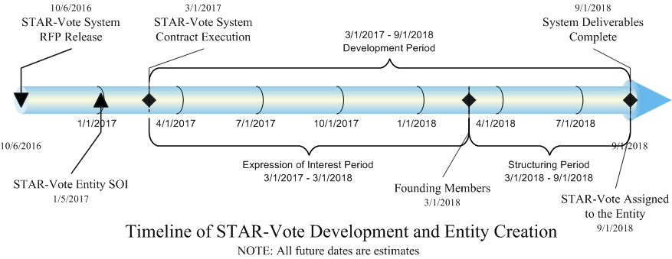

1. **Scope of Work:** The following sections outline the proposed effort that will be performed during the Structuring Period, the general model of the Entity, projections of its operation and suggested content of an expression of interest. The work effort for the Structuring Period is primarily performed by resources assigned to project by Travis County and the Founding Members, and is funded by capital contributed by the Founding Members.
   1. Entity model: As outlined herein, the Entity has been modeled to mimic the structure of existing, Open Source Software Foundations (OSSF) operating in areas of general commerce. This construct is limited only this SOI for the purpose of providing a representative model for Interested Parties to acknowledge the components of an Open Source Software Foundation (OSSF). Final determination and definition of the different factions, operating procedures, governance documentation and By-Laws will be made during Structuring Period.
   2. Operational projections: This SOI is proposing the need for funds to support the first five years of the Entity’s operation and then the Entity becomes a self-sustaining from the end of year five forward. The projections include an operating budget for the Structuring Period, operating budget for the first five years and the strategic focus of the Entity and finally, a revenue projection for years six through 10. Interested Parties are requested to declare their “Membership Type” that best fits their individual situation and to comment on any other topics contained in this SOI or present topics that should be addressed.
   3. Expression of Interest: This document outlines the objectives of the work effort for the Structuring Period and provides other projected information regarding the STAR-Vote Entity. Paragraph 7 requests written comments from Interested Parties to be optionally included in any expression of interest. Interested Parties are invited to comment on any of the information contained in this SOI.
2. **Structuring Period:** The Structuring Period begins when agreements are executed to create Founding Members and completes when the deliverables from the STAR-Vote system development are assigned to the Entity by Travis County. During this period the Entity governance policies and procedures will be drafted and agreed to by Travis County and all Founding Members. The following paragraphs define the principal activities that will be accomplished during the Structuring Period;
   1. Governance documents: The following policies will be drafted and agreed to by all parties;
      1. Bylaws: The Entity Bylaws will include a definition, specification and operating authority for the following governance bodies;
         1. Board of Directors
         2. Committees of Board and Working Group
            1. Functional Steering Committee
            2. Technical Advisory Committee
            3. Voter Community Committee
            4. Other Committees as warranted
         3. Entity Officers
         4. Membership At Large
            1. Fees, Dues and Assessment
            2. Meetings and Voting Rights
         5. Other legal clauses as customary for non-profit governance
      2. Membership Agreement(s)
      3. Member Licenses
         1. Contributor
            1. Corporate
            2. Individual
         2. STAR-Vote User
      4. Development
         1. Policy
         2. Operations
      5. Intellectual Property Policy
      6. Code-of-Conduct
         1. STAR-Vote Entity
         2. Community at-large
         3. Compulsory Conduct language: Given the nature of the product, the Code-of-Conduct documents and any other governance document that relates to internal or external interaction with the Entity will state that political opinions, beliefs or other partisan positions are strictly prohibited and can lead to expulsion or banning individuals or entities from further relationships with the Entity. The Code of Conduct will stress the necessity for the Entity to remain politically neutral.
      7. Guiding Principals
      8. Other policies as deemed appropriate by the Structuring team
   2. Obtain tax status from the IRS: 501(c)(6)
   3. Financial Management and Accounting practices
      1. Operating Budget
      2. Capital Budget
   4. Operating Procedures
   5. Staffing Plan and employment policies
   6. Development Plan
      1. Software requirements
      2. Software Project Plan
      3. Development staffing plan
   7. Certification: As voting system certification is a fairly unique product requirement for an Open Source Software Foundation (OSSF), a governance document defining the Entity’s certification management practices is warranted.
3. **Entity Membership Type:** The Entity will consist of different membership types and Interested Parties must declare their intended type with a description of their objectives for becoming a member of the Entity. The specific roles and authority of the different Member types will be defined during the Structuring Period with the participation of the Founding Members.
   1. Public User Member: A Public User Member of the Entity is an entity that intends to implement STAR-Vote for use in conducting public elections at a County or State level. This membership type has the greatest influence on the future releases of STAR-Vote.
   2. Public Interest Member: This membership type is an entity or individual that desires to support the creation and maintenance of an open source voting system to be available for use by election entities in the United States. Public Interest Members are likely to be Federal Agencies, corporations or charitable organizations/individuals with an interest in fair, open and secure voting technologies.
   3. Enterprise Members: Enterprise Members are interested in providing development resources to contribute to the STAR-Vote code base with a desire to provide implementation services to Election entities. Enterprise Members can have an interest in either hardware, software or both.
   4. Strategic Members: A Strategic Member of the Entity has an interest in providing peripheral products or services around the STAR-Vote system that supports election related functions outside of the STAR-Vote system boundary but are common practices for election cycles.
   5. Individual Contributor Member: This Membership type provides in-kind services to the Entity based on skills or experience. Individual Contributor Members can provide software development services, technical, financial or management advisory services, and typical do not include a financial contribution to the Entity
4. **Use of Funds:** This SOI proposes an objective amount of capital $25 million for the STAR-Vote Entity is $25 million, which is projected to support the five year operating budget of the non-profit and development of the remaining open source software modules and provide a cash reserve. A minimum of $15 million is required to move forward with the Structuring Period and if this minimum is not met, creation of the Entity will be abandon and Travis County will pursue realization of the STAR-Vote system through alternate means, as yet to be identified. Execution the Entity Founding Member agreements requires capital contribution for “Entity Seed Funds” that will be held in an account established by Travis County and used to finance the Structuring Period that includes paying for services related to structuring and defining the Entity’s governance policies, procedures, operations, licensing documentation, and other Entity formation. An accounting and disbursement procedure for these funds will be determined during Founding Member agreement negotiations and will become part of those agreements. The work effort for structuring the Entity will run in parallel with the latter part Development Period so that the Entity is an operational entity when the Development Period is complete. Founding Members are invited to participate in the Structuring Period but at a minimum, consensus approval of all documentation is required between the County and Founding Members. Travis County retains control of the project during the Structuring Period and will be responsible for resolving any conflicts related to forming the Entity. At the end of the $4 million Development Period, Travis County will assign, transfer or sell all right, title and interest in the STAR-Vote Entity. The asset transfer event triggers the remaining delivery of the funding provided by the Founding Members.
   1. Structuring Period Project Plan and Budget Projection: the Project Plan for the Structuring Period is outlined in Section 3.0 and consists of development of the documentation necessary for the STAR-Vote Entity to execute its purpose. In addition to the documentation, Entity staff members will be recruited and an office location secured in preparation for launching the Entity.
      1. Resources: Travis County responsible for staffing the Structuring Period project team and will assign qualified resources to the project. The projected resource requirements are:
         1. Project Manager
         2. Open Source Software Industry Expert
         3. Legal Support
         4. Administrative Support
      2. Funding: The Structuring Period resources will be compensated using the Entity Seed Funds that result from an initial capital contribution by the Founding Members. The County will retain the funds in an account and disperse funds according to financial process defined as part of the agreements with Founding Members. Any remaining funds will be transferred to the Entity at the end of the Structuring project.
      3. Budget Projection: The Structuring Period Budget Projection spreads project hours across the 6-month projected Structuring Period for the STAR-Vote Entity. This timeframe will be aligned with the final project schedule determined during contract negotiations and the hourly expenditure adjusted accordingly. The Budget Projection allows time for drafting documents and collecting feedback and input from the Founding Members.

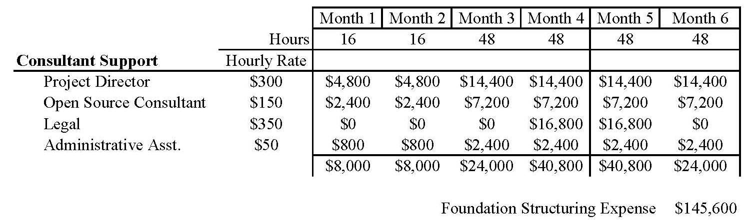

* 1. Five Year Strategic Plan and Budget Projection: The Budget Projection establishes a framework of resources and expenditures to enable the Entity to achieve its stated goals. The Five Year Plan and Budget Projection will be finalized with Interested Parties/Founding Members during expressed interest discussions that integrate the state of the STAR-Vote system development contract. The major tenets of the Five Year Strategic Plan are;
     1. STAR-Vote system Certification ready: The Entity’s Five Year Strategic Plan is predicated on the assignment of a functional voting system being assigned by Travis County. The state of the STAR-Vote system at the end of the Development Period will be forecasted during contract discussions and if the Development Period does not end with a functional system, additional development by the Entity will be required. In this situation, Travis County will assign the STAR-Vote system and the vendor contracts and the Entity will take over the development process to achieve the functional milestone(s). This is not presently accounted for in the Budget Projection but will be adjusted as required at contract negotiations.
     2. STAR-Vote Certification; Federal and State: STAR-Vote will be submitted for Federal Certification as soon as it is ready. The first version of STAR-Vote utilizes election modules that are already certified and will not require testing so the first submission will be for the In-Person Voting modules. The objective of the Entity is to submit updates to STAR-Vote every two years so a second submission is planned within the five year plan. The second submission will be for any updates to the In-Person Voting modules and the newly developed Ballot Definition, By-Mail Scanning and the Tabulation modules to replace the EAC Certified modules of the first submission. Submission of new releases of STAR-Vote will be aligned with election cycles so that new versions are available during the ‘quiet’ periods when system upgrades can be performed.
     3. Develop remaining open source election components: Development of the open source Software versions of the Ballot Definition, By-Mail Scanning and Tabulation modules will begin almost immediately with the launch of the Entity.
        1. Development Approach: A review of historical, successful open source projects revels there are a couple of different development approaches possible for the launch of an open source product. Given the status of the STAR-Vote system at the launch of the Entity and the nature of election requirements, Travis County has determined starting out with a Cathedral-type of development is the most appropriate for STAR-Vote. In a Cathedral-type of development model, a small core of dedicated contributors is employed to develop the first release of the product and its modules. The development will be transparent, open and public however the risk of creating a contribution community of sufficient mass initially is high and therefore difficult to predict a development timeline. The intent is to provide the resources necessary to keep the development on schedule while developing the contributor community and then moving to a Bazaar-type of development model once the initial release of all modules is complete. Moving to a Bazaar-type of model is a natural progression for the project and supports contribution from a broad range of technical resources that are vetted by the Entity for adoption. The Five Year Budget has allotted 22 man-years to complete this effort.
        2. Software Requirements: One of the principal factors for the initial Cathedral-type development is for drafting the software requirements for the remaining open source components. In essence, the U.S. has 50 sets of functional requirements, which creates a complex environment. The first release of the additional STAR-Vote components are not expected to satisfy the requirements for all 50 States but the components must be architected in a manner that will support future additions. Further, initial supported State requirements must be aligned with Counties that are likely to adopt STAR-Vote in the near term, which will promote the sustainability of the Entity. These requirements will be drafted internally by the Entity, reviewed by its members and will be published for public review and input.
     4. Recruit additional County and State users: Promoting STAR-Vote to other Counties and States will begin with the publication of this SOI and contracts are executed for the companion RFP for the development of STAR-Vote. Signing is expected to draw national attention to this first-of-its-kind, innovative approach toward support for US elections, plus the election community is well defined providing a straightforward channel for direct communication. The voting system sales cycle is long and election officials are cautious so proof of functionality and accuracy are necessary. A tremendous advantage of STAR-Vote is that it possesses an early adopter, Travis County, which will demonstrate the effectiveness of the system to other election officials. Continued publicity, demonstrations and certification will all drive new counties to adopt STAR-Vote for their jurisdictions.
     5. Establish an Election Support Desk: The nature of elections and the resources used to conduct them warrants the Entity provide system expertise for member jurisdictions to support election cycles. Jurisdictions possess election expertise and Information Technology resources but do not typically maintain resources with voting system expertise, which is necessary to address any technical issues that may arise during an election cycle. System issues must be quickly resolved to allow the election to proceed without interruption.
     6. Promote the contributor community: Development of the contributor community begins early on with the Structuring Period and initial STAR-Vote development.
     7. Budget Projection: A summary budget projection is provided in the table below with projection details for review upon request. The budget projection is based on the following assumptions:
        1. The STAR-Vote Development Period conducted by Travis County results in a functional STAR-Vote system that is ready for Federal certification.
        2. Resources for staffing the Entity are secured during the Structuring Period and are able to start when the Entity is launched.
        3. The STAR-Vote system assigned to the Entity is submitted for Federal certification and is completed within the first year with support from the vendors from the STAR-Vote system RFP.
        4. The effort to draft the software requirements for the remaining open source STAR-Vote components begins on Day 1.
        5. Up to four States are targeted for certification in Year 2, where some States have more complex certification processes.
        6. Development of the remaining open source STAR-Vote components is completed in Year 3.
        7. Certification of the complete open source STAR-Vote system is accomplished in Year 4. The certification cycle continues into the future where re-submission for certification occurs every two years to result is a new release being available for Members every two years as well.
        8. Up to four States are targeted for certification in Year 5, where some States have more complex certification processes.
        9. The five year budget relies solely on financial support garnered from this SOI and not on any new Memberships in years 1-5.
        10. Budget Projection Summary:

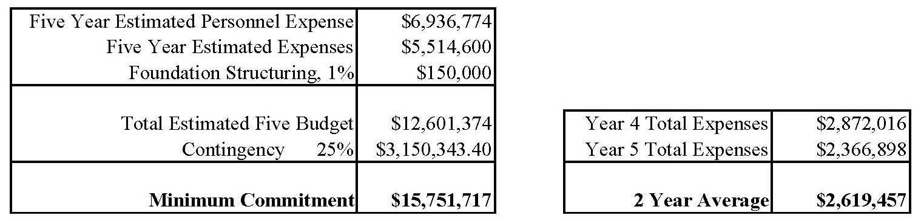

1. **Entity Revenue Module:** The purpose of this SOI is to generate interest for Interested Parties to become Founding Members of the STAR-Vote Entity and to participate in financing the of it for the first five years of operation with the objective for the Entity to be self-sustaining thereafter. The principal, on-going expenses for the Entity stem from managing the code base and development, certification, maintaining an election support desk and the staff required to conduct these efforts. Travis County is recommending a revenue model that is based on Entity Membership fees and an on-going annual fee for election support desk. Only Entity Public User and Enterprise Members are provided access to the certified versions of STAR-Vote and use of the election support desk, which provides compelling motivation to become Entity Members. The suggested rates and revenues are provided as a general outline of a revenue model, which is expected to be refined and adjusted with the Founding Members during the Structuring Period. The following paragraphs outline the assumptions used in building the exemplary revenue model followed by a summary table of the detailed projection, which is available upon request;
   1. New Public User Members: Joining the Entity requires new Public User Members to pay a one-time membership fee. The membership fee gives access to the certified version of the STAR-Vote software and the opportunity to access the Election Support Desk. An initial rate for the membership fee has been based on the proportional equivalent of the initial Travis County investment. Certified software updates are currently planned for every two years, which is subject to change.
   2. Annual Public User Membership Fee: On-going support and services provided by the Entity are funded in part by an annual fee paid by Public User Members. The Entity will maintain a support staff that is knowledgeable of the STAR-Vote software at an engineering level to provide election support when technical issues arise. The annual fee also assists in funding the periodic system certification every two years. The present projection for the amount of the fee used in the revenue projection is $0.05 per County resident. It is likely the rate will be based on registered voters or voting age population, which will be determined during the Structuring Period. Furthermore, the annual rate may be adjustable over time, as agreed to by the Entity membership, to help manage the Entity’s financial health and to achieve the lowest cost of ownership for Public User Members.
   3. New Public Interest Member: The Entity will permit admission of new Public Interest Members under a variety of circumstances. Membership fee(s) for these additions will be individually negotiated for both new memberships and annual support.
   4. Enterprise and Strategic Members: These member types are important to the longevity of the Entity and the scope of available support and services surrounding the STAR-Vote system. There are a number of proven models in the Open Source Software community that will be applied as appropriate for the definition of the financial requirements for these member types and will likely include some small percentage of revenue that is generated based on services provided for and peripherally to the STAR-Vote system. The participation requirement will be defined as part of the Entity Structure Period and revenue generated from these member types was not included in the revenue projection.
   5. Revenue Summary: The primary purpose for the inclusion of a revenue projection is to provide a framework that demonstrates the ability of the STAR-Vote Entity to be self-sustaining after five years of operation through financing provided by the Founding Members and through on-going revenue generation. As noted above, the fees and rates may be adjusted during the Entity Structure Period but the projection show that even at a low adoption rate, the Entity is a viable on-going entity. Greater detail for the revenue projection can be provided on request and the following paragraphs provide relevant information when reviewing the summary.
      1. Public User Members are shown as cumulative to demonstrate the growth of the Election Support Desk Annual fees.
      2. Enterprise and Strategic Member revenue: No estimates for these revenues are provided due the lack of certainty that any estimate would provide. These revenues are not expected to provide a major impact on the Entity’s financial health. The benefit of the member types is the additional support and services provided but will nonetheless supply an incremental amount of revenue.
      3. Revenue Projection:

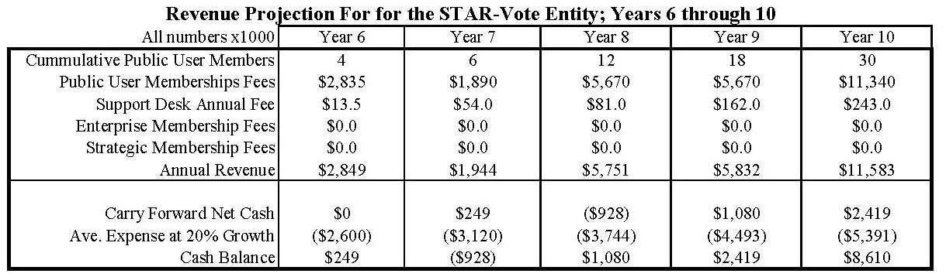

1. **Financial Contribution:** The objective of this SOI is to generate interest for Interested Parties to become Founding Members of the STAR-Vote Entity and to participate in financing the of it for the first five years of operation with the objective for the Entity to be self-sustaining thereafter. The proposed level of funding for the STAR-Vote Entity is at a sufficient level to ensure its continued success in supporting an open source Software voting system for use in US elections. The entire STAR-Vote project has been a bold and ambitious undertaking and financing the Entity embraces these characteristics. The financial objective is to secure $25 million in commitments to the Entity, where $15 million is for the first five years of operation and $10 million as a cash reserve, the latter to provide other counties the assurance of the Entity’s continued existence in the face long adoption times and long product life-cycle. The following items outline suggested information to be included in an expression of interest or that would be the discussion topics for follow up with Travis County.
   1. Interest Parties are requested to propose a level of contribution to the Entity to become a Founding Member.
   2. If the proposed contribution is to be provided to the Entity as installment contributions, outline an installment plan.
   3. If there are any conditions that must be met prior to the launch of the Entity, outline these conditions.
   4. If there are any restrictions that must be imposed on the contribution, outline these restrictions.
   5. If proposing installment contributions and there are any conditions or restrictions on continued installment payment, outline these in the proposal.
   6. Select a Membership Type as outlined section 2.0 that most closely represents your intention for participation. Also include any specifics or variations in the Membership Type that would more accurately define your intention for membership, including any services, support or peripheral election products or services.
   7. Include a description of your willingness and availability to review, author or otherwise participate in the development and production of governance policies and operational procedures for the Entity prior to its launch. Please identify any specific resource or resources that would represent your entity for this effort.
   8. Include a description of your entity’s willingness and availability to accept an appointment or appointments to any of the governance bodies contemplated in this SOI, including the Entity Board of Directors or other governance body. Please identify any specific resource or resources that would be available for such appointment(s).
   9. Structuring Period Funding: Travis County is funding the initial development of STAR-Vote, paying for the support costs for the RFP and has agreed to assign, transfer or sell STAR-Vote to the Entity at the end of the $4 million Development Period. The Entity must be born, created and launched independent of Travis County and therefore, the County should not fund the Structuring Period. To provide independent funding for this effort, Interested Parties are requested to address their willingness participate financially in funding some portion of the Structuring Period.
   10. Contribution Amounts: The following provides a general discussion for contribution amounts for Interested Parties/Founding Members. Travis County cannot set required contribution amounts and these discussion points should be considered in conjunction with the “Contribution Leveling” process given in section 7.12 below.
       1. Public User Members: Travis County has established a baseline for potential Public User Members through the investment of $4 million for the initial development of the STAR-Vote system. This amount has a much greater value however as the initial development phase has the highest risk and the $4 million does not include the tens of thousands of dollars already spent to bring the STAR-Vote project to this stage. Nonetheless, $4 million dollars is roughly one-quarter of the cost to replace Travis County’s voting system with a commercially available, traditional proprietary voting system, or about $3.50 per registered voter.
       2. Public Interest Members: Travis County recognizes that this project is unlikely to be successful without one or more major benefactors. The County has opened up membership to the STAR-Vote Entity for Federal agencies, charitable entities or foundations, and even individuals with an interest in supporting this unprecedented project.
       3. Enterprise and Strategic Members: These membership types are important to the STAR-Vote community and Travis County urges interested entities to submit a response. By submitting a response, these members will be able to participate in the Structuring Period and help define the interface between the Entity and member’s commercial interest. It is in the Entity’s best interest to include a diverse set of input when drafting the governance documentation that will address the relationship with Enterprise and Strategic Members.
       4. Individual Contributor Member: No financial contribution is expected from prospective Individual Contributor Members. If submitting an expression of interest as this member type with a desire to participate in the Structuring Period, provide a description of an area of expertise and desired level of participation.
   11. Contribution Leveling: Travis County acknowledges the difficulty Interested Parties may have in determining the amount of a financial commitment and the County is uncertain of the response to this SOI. The County is therefore including a “Contribution Leveling” concept that has several attributes;
       1. Diversity of Membership: STAR-Vote will be best served by a membership from a diversity of interests. Based on receipt of expressions of interest to the SOI, Travis County will ‘negotiate’ levels of contributions with individual Interested Parties. This approach is intended to prevent any one Interested Party/Founding Member from dominating the Entity and also provides assurance that financing the Entity will be spread across a diverse set of Interested Parties.
       2. Downward Leveling: In the fortunate circumstance where Travis County receives an abundance of interest over the amount that is sought, the County will approach Interested Parties to reduce their proposed contribution.
       3. Upward Leveling: In the unfortunate circumstance where Travis County receives an underwhelming interest, the County will approach the Interested Parties to determine if they would increase their proposed amount. If this situation is not resolved through the Interested Parties, the County may need to abandon the project and explore alternate approaches.